**Investigating Exercise Effect on Resting Heart Rate**

**By Nicole Whittle**

**Introduction:**

The cardiovascular system is a bodily system made up of 3 main components: the heart, lungs and blood vessels. The system works together to deliver oxygen and nutrients to other organs within your body while excreting waste through the blood flow (Cleveland Clinic, 2021). The heart is a crucial component of physiological health, as having a healthy heart comes with many bodily benefits such as decreasing the risk of heart attacks, high blood pressure and development of heart diseases (Heart Foundation, N.D). This investigation aims to discover how regular exercise has an effect on adolescents resting heart rate. RHR (Resting Heart Rate), or in other words pulse, is a physiological measurement that refers to the number of times your heart beats per minute, to efficiently deliver blood around the body. Heart rate can rise depending on several factors such as caffeine intake or influences of drugs like nicotine or alcohol (Beckerman J, 2022). Emotions can also cause an increase in heart rate, such as anxiety, anger, and depression, due to the release of hormones.

However, the aim of this investigation solely focusses on exercises’ effect on an individual’s resting heart rate. Vigorous exercise causes an increase demand of cardiac output, due to the demand of oxygen in the body’s muscles while exerting (Healthwise, 2020). However, although vigorous exercise affects your pulse in a relatively short period of time, studies show that regular exercising can cause an overall decrease in resting heart rate (Oh D, & Lee B, 2016). This is because exercise helps strengthen the heart muscle and increase it’s efficiently, allowing more oxygenated blood to be pumped around the body. Researchers also state that if an aerobic function is performed over a long period of time, it can influence changes to the parasympathetic nervous system, such as increasing stroke volume (amount of blood being pumped out) and decreasing resting heart rate (Oh D, & Lee B, 2016). This investigation specifies on teenagers, as habits and behaviours during adolescence can make a prediction on how their cardiovascular health will be in the future.

**Hypothesis:**

It is hypothesised that teenagers aged 15-16, that perform more exercise per week, will have a lower resting heart rate, than teenagers who exercise less. It can be tested by calculating each individual’s resting heart rate (BPM). This prediction stems from past studies which show that individuals who exercise regularly, tend to have an overall lower heart rate due to changes in their autonomic nervous system, linking to the cardiovascular system.

**Table of Variables:**

|  |  |
| --- | --- |
| Independent | Number of times teenagers exercise each week |
| Dependent | Resting heart rate of each student |
| Controlled | Age (15-16) and school which they attend |
| Extraneous | Any past medical history teenagers could have or mental health disorders |

**Materials Required:**

* Task sheet
* At least 20 participants (Adolescents)
* Timer
* Laptop (to track results)
* Graph Paper
* Pens
* Ruler
* Calculator

**Method:**  
1) Gather all required tangible materials such as a timer, laptop, calculator, and a participant

2) Allow participant to remain seated for at least 2 minutes

3) Question how many times they exercise per week, on average

4) Record their weekly exercise amount

5) Find participants pulse on wrist (between wrist bone and tendon on thumb side) or on the side of their neck

6) Set up timer and record number of pulses you feel within 60 seconds

7) Record total amount of heart beats

8) Repeat above trial 3 times for accurate results

9) Use a calculator to calculate the individuals average BPM-> You can accomplish this by adding all the trial values and then dividing it by 3 (total amount of trials done)

10) Repeat the above procedure for all participants for this investigation, and record all results

11) Calculate overall average for each group (based on amount of days exercise takes place)

**Reliability**:

The consistent method ensures that all results can be reliable when linking the effects on heart rate. With the repetition of trials while measuring each individual’s resting heart rate, helps produce a sufficient and reliable average bpm.

**Validity:**

The procedure enforces that all participants are aged between 15-16, while also controlling their year group (Year 11). This helps produce valid results that make the data become more related to adolescents in another population. By doing this the investigations validity increases because no outliers are present in the investigation, such as an adult’s heart rate.

**Results:**

**Raw Data:** Colour coordinated depending amount of days exercise takes place on a weekly basis.

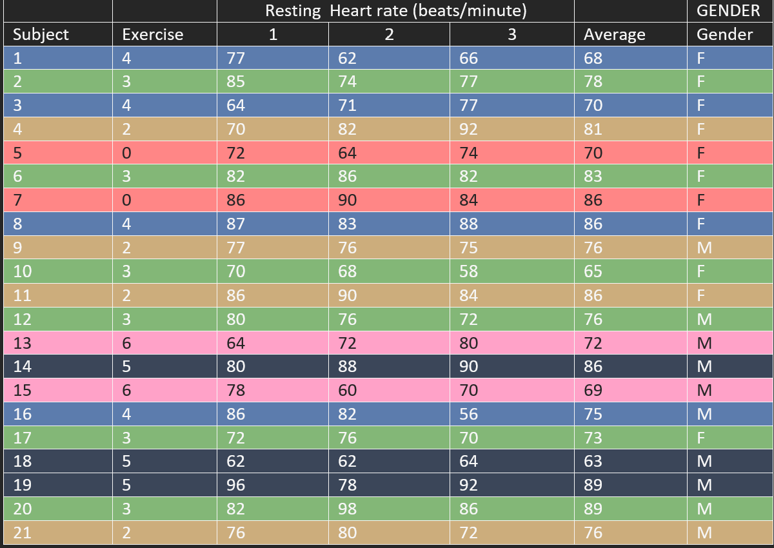

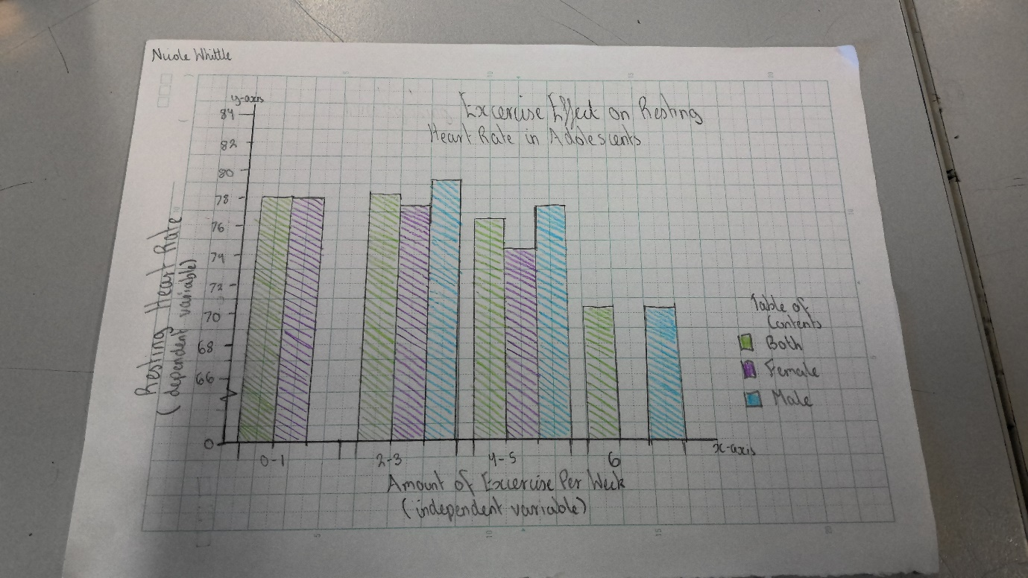

**Graph:** Contains average bpm for each amount, within 3 classified groups (Gender and combined)

Reference List:

heartfoundation-prod.azurewebsites.net. (n.d.). *Keeping your heart healthy | The Heart Foundation*. [online] Available at: <https://www.heartfoundation.org.au/bundles/healthy-living-and-eating/keeping-your-heart-healthy>.

WebMD. (n.d.). *Your Heart Rate*. [online] Available at: <https://www.webmd.com/heart-disease/heart-failure/watching-rate-monitor#091e9c5e80007973-1-4>.

Cleveland Clinic (2021). *Cardiovascular System: Overview, Anatomy and Function*. [online] Cleveland Clinic. Available at: (<https://my.clevelandclinic.org/health/body/21833-cardiovascular-system>)

Oh, D.-J., Hong, H.-O. and Lee, B.-A. (2016). The effects of strenuous exercises on resting heart rate, blood pressure, and maximal oxygen uptake. *Journal of Exercise Rehabilitation*, [online] 12(1), pp.42–46. doi:(<https://doi.org/10.12965/jer.150258>.)

Healthwise (2020). *Cardiac Output*. [online] myhealth.alberta.ca. Available at: <https://myhealth.alberta.ca/Health/Pages/conditions.aspx?hwid=tx4080abc#:~:text=During%20exercise%2C%20your%20body%20may>.